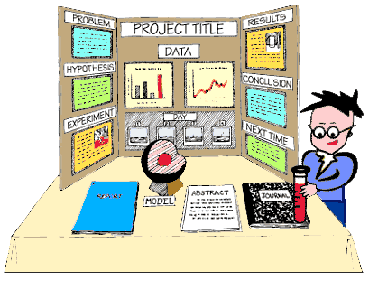

Powerstown Educate Together National School

Science Fair
9th March 2018

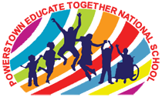
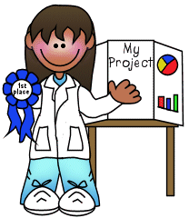Save the date!
What: PETNS Science Fair
When: The PETNS Science fair will take place on Friday the 9th of March!

What is a Science Fair Project?
A science fair project is a unique way for students to pose questions for which they must seek out answers and to satisfy their own curiosity about the world around them. A science fair project is an experiment, a research effort, a collection of scientific items, or display of scientific tools presented for viewing. It represents the efforts of a student's investigation into some area of interest and provides a way for the student to share the results of those investigations. Through the development of a science fair project, students gain a first-hand appreciation of the work of scientists and the value of their discoveries.

PETNS Science Fair Project Rules & Guidelines:
- A project should include a display board and any important hands-on objects. Students are expected to be able to share/discuss their project with the judges. Presentations will be conducted during school on Monday the 10th of March.
- The display board may be a typical trifold display board available at local stores such as Easons, or it may be any type of free-standing cardboard. The display board must stand upright.
- Projects should include a title, clear description of what is being investigated, and what was learned. Graphs, charts, photos and other visual aids are encouraged.
- The project should be completed by the student at home. Parents may assist students where safety is an issue (drilling, cutting, etc.).
- The project should include the child’s name, class and teacher.
- Using the scientific method is strongly encouraged, but not required.

Some Science project ideas:
- Sometimes, one of the hardest parts of planning a Science Fair project is figuring out what to do and where to start. Below are various resources to help you think about what kind of Science Fair project you want to complete. The following are Science Topics covered in Junior Infants through to 6th class to help guide you as you look to pick out a Science Fair topic...

Junior & Senior Infants:
- 5 senses
- Magnets
- Physical properties of objects
- Properties of water - solid, liquid, gas (Flow of Water/Sink or Float)
- Plant and Animal Life Processes and Needs
- Shadows
- Weather Observations
- Reduce/Reuse/Recycle

1st & 2nd Class:
- Magnets (attract, repel, applications of magnets)
- Plant and Animal Life Cycles
- Weather Patterns, Types of Storms, Day/Night
- Water Cycle
- Seasonal Changes
- Weathering and Erosion
- Plants produce oxygen and food, are a source of useful products, and provide benefits in nature
- Plant Products

3rd and 4th Class:
- Animal and Plant Life Cycles
- Adaptations (physical/behavioral/learned/instinct)
- Ecosystems and Environments (terrestrial,
- aquatic, populations, communities)
- Food Chains
- Environments (human impact, conservation
- of resource renews, effects of fire, flood,
- erosion on organisms)
- Water Cycle
- Soil
- Earth Patterns (Day/Night, seasons, tides, moon phases)
- Renewable Resources
- Types of Energy
- Simple Machines

5th and 6th Class:
- Sound
- Earthquakes; Volcanoes
- Light
- Living Systems/Cells
- Ocean Life
- Forest Life
- Types of Energy
- Plant Anatomy
- How plants make food
- Solar System
- Electricity (open/closed circuits; electromagnets)
- Force and Motion

How to present your project:
This is an example of a neat looking Science Fair Display Board. It is just an example. Depending on your information and the amount pictures, tables and graphs, you may have a different layout. Just make sure it is neat and easy to read!
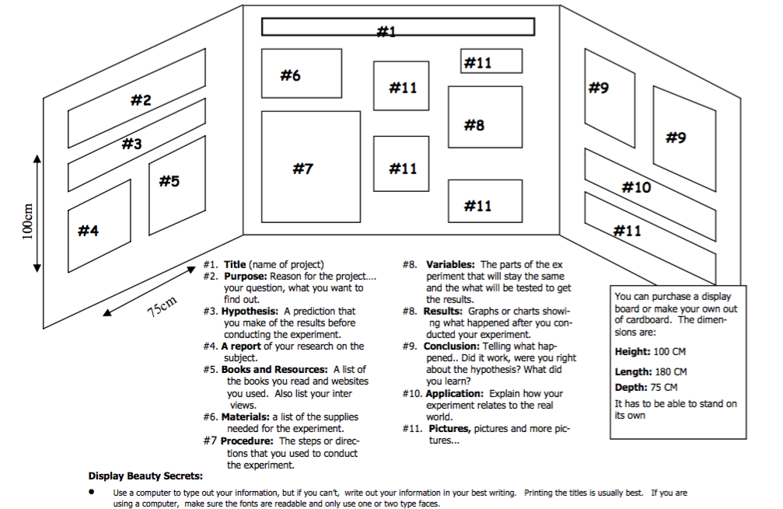
How does it look?
Create a display board so your findings can be shown at the science fair. It is a summary of your project and reflects your journal. This is your showcase. Make it creative and colorful. Below are ideas for a great display board.
  - Title of your project at the top.
  - Show all the steps of the Scientific Method process with a brief explanation of each: question, research, hypothesis, experiment (materials, procedure, variables, and data gathered that is organized in a chart or table), analysis (graph and graph explanation), and conclusion.
  - Well-organized and easy to follow from one idea to the next.
  - Neat, edited, and without scribbles and misspelled words.
  - Creative, pleasing to look at, colorful, with different font sizes to show emphasis.
  - Photos of the developing experiment.
  - Drawn pictures, artwork, and icons that bring out the ideas of the experiment.

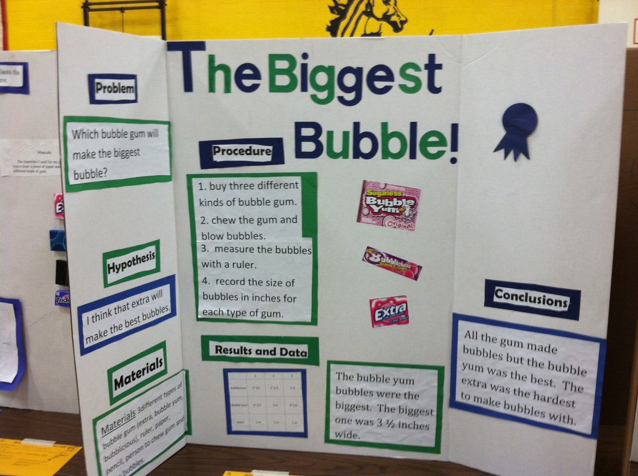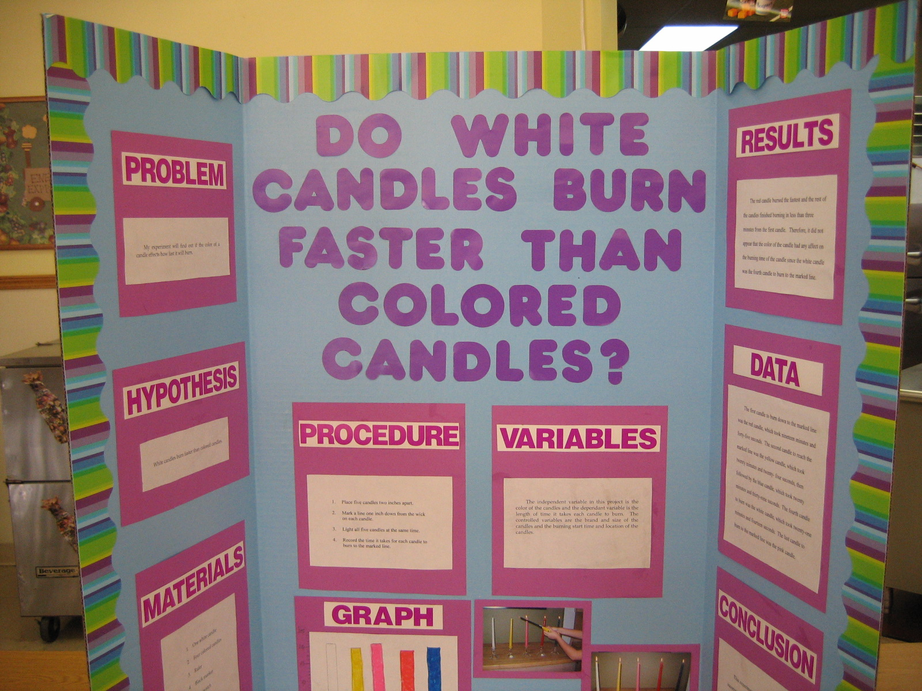
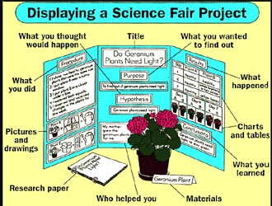

What is the scientific method?
The Scientific Method process is used to investigate a scientific question. It is a natural process scientists use to find an answer to their science questions. There are 6 steps to the scientific method:

1. Purpose: Begin by writing a specific question about a science concept that can be answered by following the Scientific Method process.

2. Research: You need to research your topic using library materials, Internet sites, magazines, textbooks, encyclopedias, experts, and other available and reliable sources.

3. Hypothesis: This is your prediction of what you think the results of the experiment will be, based on your research. Write the hypothesis in a way that will help answer the purpose (question). E.g. “If I fill up a playground ball with more air each time before I bounce it, then it will bounce higher each time.”

4. Experiment: The experiment tests the hypothesis. The experiment is broken down into 4 parts as listed below
- List of materials needed.
- The Step-by-step procedure of how you did the experiment.
- Observing, measuring, and recording data
- Organizing the data

- 5. Analysis: To analyze is to try to understand what happened during the experiment and what the data means.

6. Conclusion: The conclusion shows evidences of what you learned. It summarizes your learning by answering some of these questions: Did the results confirm or conflict with the hypothesis? What was learned from the experiment? Are there any suggestions or new questions to investigate? Were there any surprises in the results? Why was this investigation important? What does this experiment tell about the real world? How can this information be applied to real life? What new insights were discovered that weren’t known before?
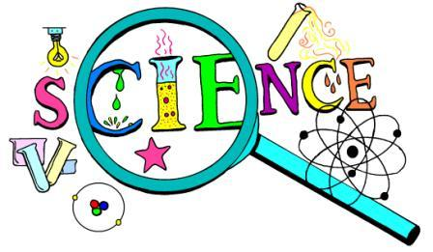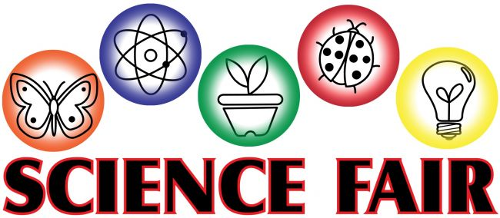
Powerstown Educate Together National School
Roll number 20384J
Powerstown Road, Tyrrelstown, Dublin 15.
Telephone: 01 8262552
Email: info@powerstownet.com
www.powerstownet.com

Dear Parent/Guardian, Date:

Your child is about to begin his/her science fair project! It should be a fun learning opportunity for your child. This guide may be helpful during the next several weeks. Please remember:
- As a parent, your job is only to assist. This is an opportunity for your child to think and act like a scientist, and to create and discover his or her very own science project!
- Please allow your child plenty of time to make mistakes. He/she might even need to start the experiment again. Remember, real scientists constantly redo their studies by starting over again.
- For safety reasons, please be available to assist your child with research and any portions of the experiment that may pose a safety risk.
- Please make time to visit the public library and use the Internet to assist your child with project research.
- It is recommended that you purchase the display board as soon as possible. Most craft stores, office supply stores, and superstores carry display boards for science fair projects.
- Remember, this is a multipart project. Your child must complete the science journal, research paper, display board, and presentation in order to receive full credit.

Thank you for your continued support!

________________________________________
Teacher Signature

------------------ CUT AND RETURN ---------------------

My child and I have read the Science Fair Student Guide in its entirety. We understand it is to be completed at home, know when each section is due and that the project display board must be completed, brought and presented to the school by Thursday March 8th.

________________________
Parent/Guardian Signature

