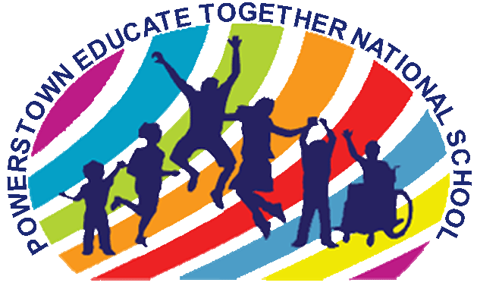
Powerstown Educate Together National School
Roll number 20384J
Powerstown Road, Tyrrelstown, Dublin 15.
Telephone: 01 8262552
Email: info@powerstownet.com
www.powerstownet.com

Dear Parent/Guardian, Date:

Your child is about to begin his/her science fair project! It should be a fun learning opportunity for your child. This guide may be helpful during the next several weeks. Please remember:
- As a parent, your job is only to assist. This is an opportunity for your child to think and act like a scientist, and to create and discover his or her very own science project!
- Please allow your child plenty of time to make mistakes. He/she might even need to start the experiment again. Remember, real scientists constantly redo their studies by starting over again.
- For safety reasons, please be available to assist your child with research and any portions of the experiment that may pose a safety risk.
- Please make time to visit the public library and use the Internet to assist your child with project research.
- It is recommended that you purchase the display board as soon as possible. Most craft stores, office supply stores, and superstores carry display boards for science fair projects.
- Remember, this is a multipart project. Your child must complete the science journal, research paper, display board, and presentation in order to receive full credit.

Thank you for your continued support!

________________________________________
Teacher Signature

------------------ CUT AND RETURN ---------------------

My child and I have read the Science Fair Student Guide in its entirety. We understand it is to be completed at home, know when each section is due and that the project display board must be completed, brought and presented to the school by Friday March 10th.

________________________
Parent/Guardian Signature

